Revision questions on Human Biology

1. Write the functions of the following ------ Oxford 9 text: Page: 50 - 51
2. Cerebrum: ---------------------------------------------------------------------------------------------------------------------------------------------------------------------------------------------------------------------------------------
3. Cerebellum: -------------------------------------------------------------------------------------------------------------------------------------------------------------------------------------------------------------------------------------
4. Medulla: -------------------------------------------------------------------------------------------------------------
5. Name two parts of peripheral nervous system.

---------------------------------------------------------------------------------------------------------------------------

1. Name two parts of autonomic nervous system.

--------------------------------------------------------------------------------------------------------------------------------

1. What is the function of central nervous system?

--------------------------------------------------------------------------------------------------------------------------------------------------------------------------------------------------------------------------------------------------------------------------------------------------------------------------------------------------------------------------------------------------------------------------------------------------------------------------------------------------------------------------------

1. What are effectors?

----------------------------------------------------------------------------------------------------------------------------------------------------------------------------------------------------------------------------------------------------------------

1. 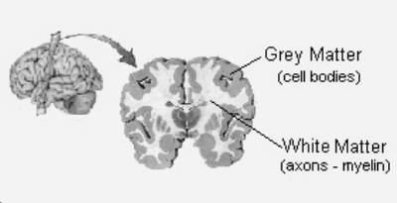

Use the picture to identify:

Grey matter contains: ----------------------------------------------

White matter contains: -------------------------------------------